**File Directory**

**Mandatory:**

1. **Search and display all *.c and *.h files in all subdirectories starting from current directory**

**Ans: ls *.c ls *.h**

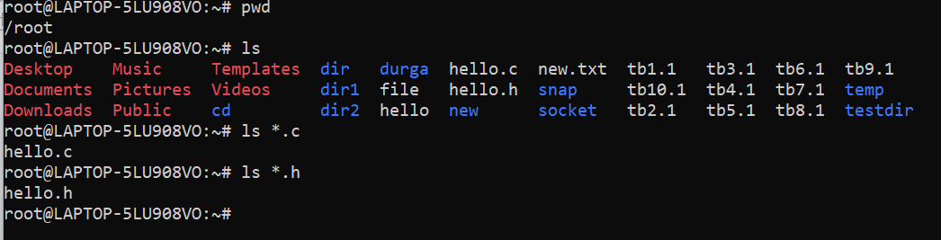

1. **Search and display all directories in all subdirectories starting from current directory**

**Ans: pwd**

**ls**



1. **Search and display all files with permissions only rw with user and execute permission for others**

**Ans: chmod u=rw,g=rw,o=rw filename**

